Activity: Gene Transcription
DNA to Protein Overview
Participant Guide

Description and Estimated Time to Complete
This is second of two activities in the DNA to Protein Learning Module. This activity provides a mechanism that allows you to apply your knowledge in transcribing and translating a gene. While completing this activity, visualize how this information can be applied to bioMEMS applications.

Estimated Time to Complete
Allow approximately one hour.
Introduction
Most of the properties of living organisms ultimately arise from a class of molecules known as proteins. Proteins are polymers composed of subunits known as amino acids. These linear polymers fold into specific three-dimensional structures with specific, unique functions. Amino acids dictate the structure of the protein. The linear sequence of information found within a gene in an organism's DNA dictates the order of amino acids.

The emerging field of proteomics is analyzing the complex range of protein expression within cells. Biologists use this information to create micro protein arrays on chips. These arrays investigate both the interactions of the arrayed proteins with other proteins as well as their potential for chemical modification. These micro protein arrays and their electronic interface are microelectromechanical systems or MEMS.

The design and fabrication of MEMS rely on an understanding of the way in which information encoded digitally in DNA translates into a functional protein. The following activity allows you to further your understanding of DNA, the genetic code and DNA transcription and translation.
Activity Objectives and Outcomes
Activity Objectives
- Use the genetic code to predict the amino acid structure of a protein

Activity Outcomes
Upon completion of this activity and the Activity: Protein Structure and Function, you will have gained an understanding of the information flow within a biological system as an aid to understanding BioMEMS applications. You will be able to use the genetic code to interpret a sequence of DNA and predict the encoded polypeptide.

Activity: Transcribe and Translate a Gene
Description
This activity allows you to apply your knowledge to transcribe and translate a gene using The Genetic Code.

Procedure:

- Go to Learn.Genetics – Basic Genetics. http://learn.genetics.utah.edu/content/basics/
- Review the following tutorials:
  - “What is Inheritance”: http://learn.genetics.utah.edu/content/basics/inheritance/
  - “Transcribe and Translate a Gene”: http://learn.genetics.utah.edu/content/basics/transcribe/
  - “RNA: The Versatile Molecule”: http://learn.genetics.utah.edu/content/basics/rna/
  - “RNA’s Role in the Central Dogma”: http://learn.genetics.utah.edu/content/basics/centraldogma/ - Click on various parts of the graphic for more information.
  - “Beyond the Central Dogma”: http://learn.genetics.utah.edu/content/basics/beyond/
- Answer the Post-Activity Questions.

Post-Activity Questions / Answers
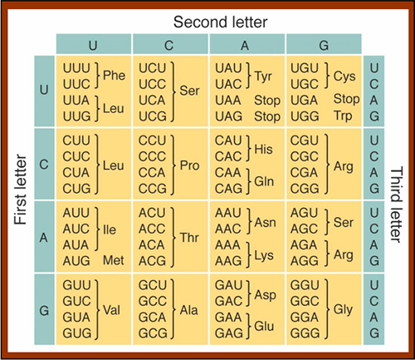
The Genetic Code
- What is the nucleotide sequence of the complementary strand of this DNA molecule: AATGCGA?

- What is the nucleotide sequence of the mRNA transcribed from this DNA molecule: TACAAAAAG?

- If the mRNA sequence you obtained in question 2 were to be translated, what would be the sequence of amino acids?

- Does every possible triplet in the genetic code specify an amino acid?

- If a polypeptide contains 146 amino acids, what is the minimum number of nucleotides required in the mRNA from which this polypeptide is translated?

- What is a bioMEMS applications in which a strong understanding of the genetic code is important?

Summary
Deciphering the genetic code has allowed scientists to translate the sequence of DNA into the sequence of amino acids that comprise the primary structure of a protein or polypeptide. Protein structure is related to function, and proteins fulfill a wide diversity of functions within cells. Proteins are also an integral part of many diagnostic aids and devices.
References
- Fundamentals of BioMEMs and Medical Microdevices. Steven S. Saliterman. Wiley Interscience. 2006.
- Life: The Science of Biology, 8th edition. Sadava et.al. Freeman. 2007.
- Bioinquiry, 3rd edition. Pruitt and Underwood. Wiley. 2006.
- Genetics: From Genes to Genomes, Hartwell et.al., McGraw Hill. 2008.
- Learn Genetics, Genetic Science Learning Center. University of Utah. http://learn.genetics.utah.edu
- The Biotechnology Project. Madison Area Technology College. Proteins Unit 1: Why Proteins?
Support for this work was provided by the National Science Foundation's Advanced Technological Education (ATE) Program through Grants. For more learning modules related to microtechnology, visit the SCME website (http://scme-nm.org).

This Learning Module was developed in conjunction with Bio-Link, a National Science Foundation Advanced Technological Education (ATE) Center for Biotechnology @ www.bio-link.org.

