SPC Resistance Measurement Activity
Participant Guide

Activity Description

Statistical Process Control or SPC is a set of tools used for continuous improvement and the assurance of quality in an active manufacturing process. This quality control method uses statistical techniques to monitor a process by providing tools to determine when a process is running correctly or has begun to produce undesired results.
The purpose of this activity is to apply your knowledge of SPC to determine whether or not your process is operating as it should. You use historical data to construct a control chart with the statistically appropriate parameters. You then take resistance measurements of process samples, plot them on your chart and analyze the results.

Objectives
- Use historical data to construct a control chart.
- Measure resistance values of process samples and plot the resistance values on your control chart.
- Using the Shewhart Rules (Western Electric Rules), determine if your process is in control.

Introduction

Activity Scenario: You work in a factory that produces small conductive rods, 6 cm in length, approximately 0.7 mm in diameter. The rods are packaged in batches of 15 rods. The material used to manufacture the rods is graphene. Graphene is a conductive material, thus it carries electrical properties.
It is your job to determine if the process is producing rods within a specified range of resistance values based on the historical data (previous production results). SPC charts are used to monitor these resistance values. However, before determining is the current process is “in-control”, you must first use historical data to construct the control charts. You are given a set of historical resistance measurements for 20 different batches of rods from which you design the control charts for rod processing.
Supplies / Equipment
- A batch of 6 cm long graphene rods. (Each batch contains 15 individual rods)
- A voltmeter with mini test clip adapters
- A sample set of historical data to calculate SPC chart parameters (included)
- SPC chart template (attached)
- Data collection template (attached)

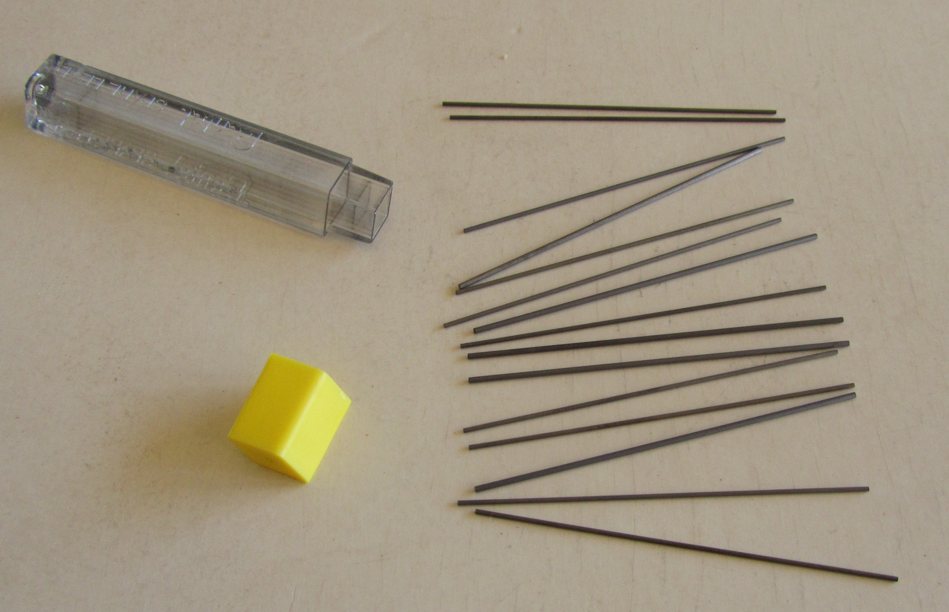
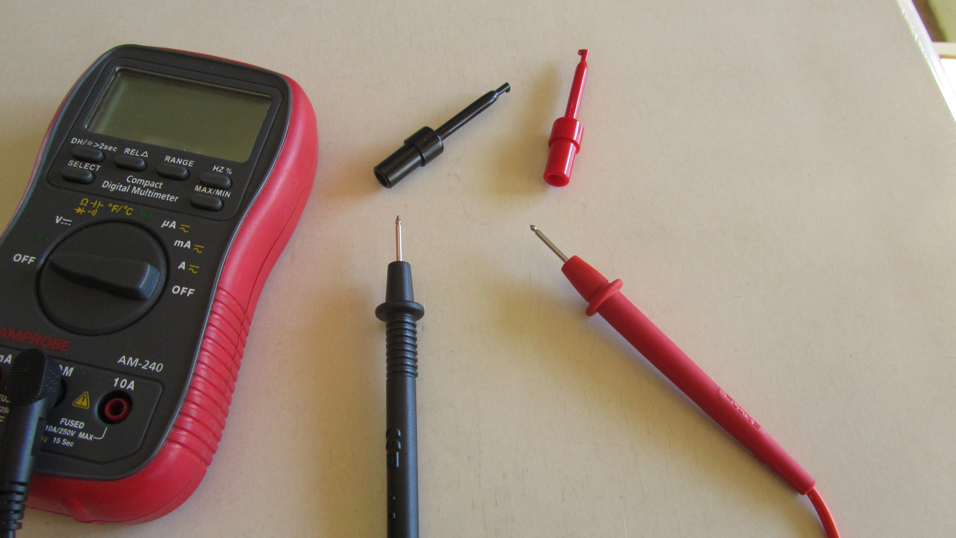

Voltmeter with probes and mini test clips
One batch of 15 conductive rods

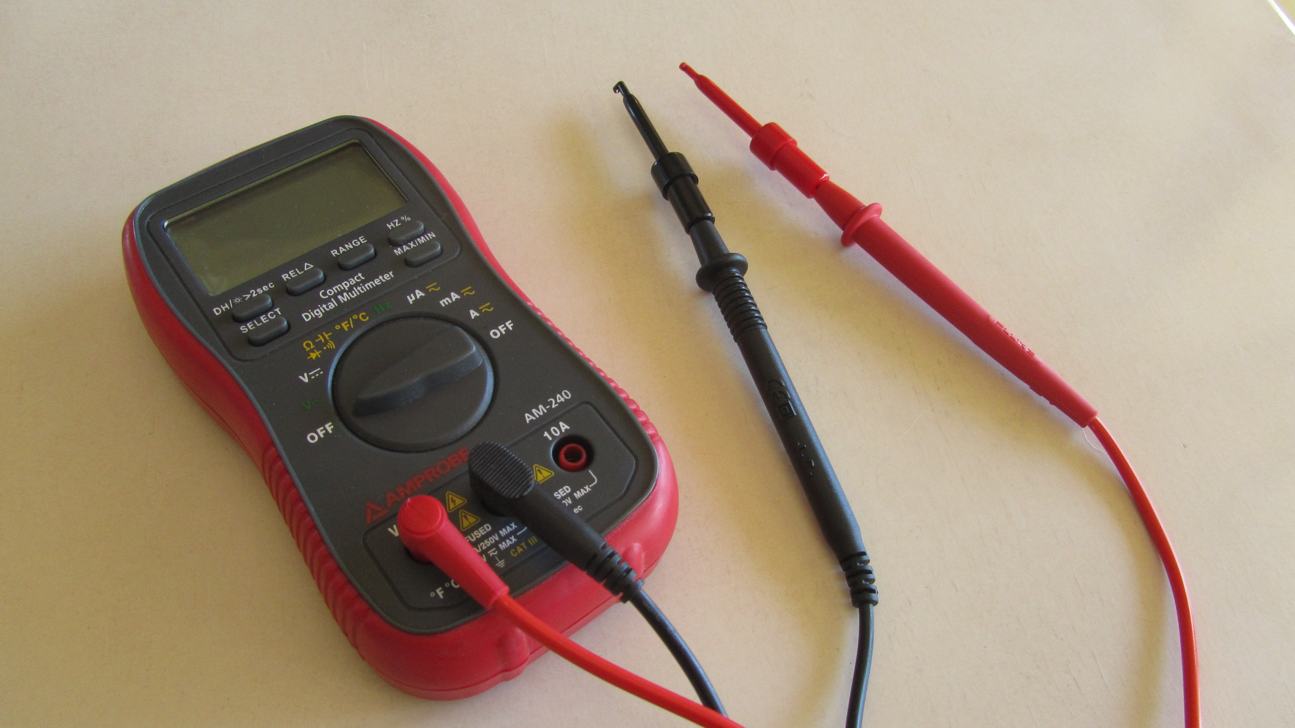
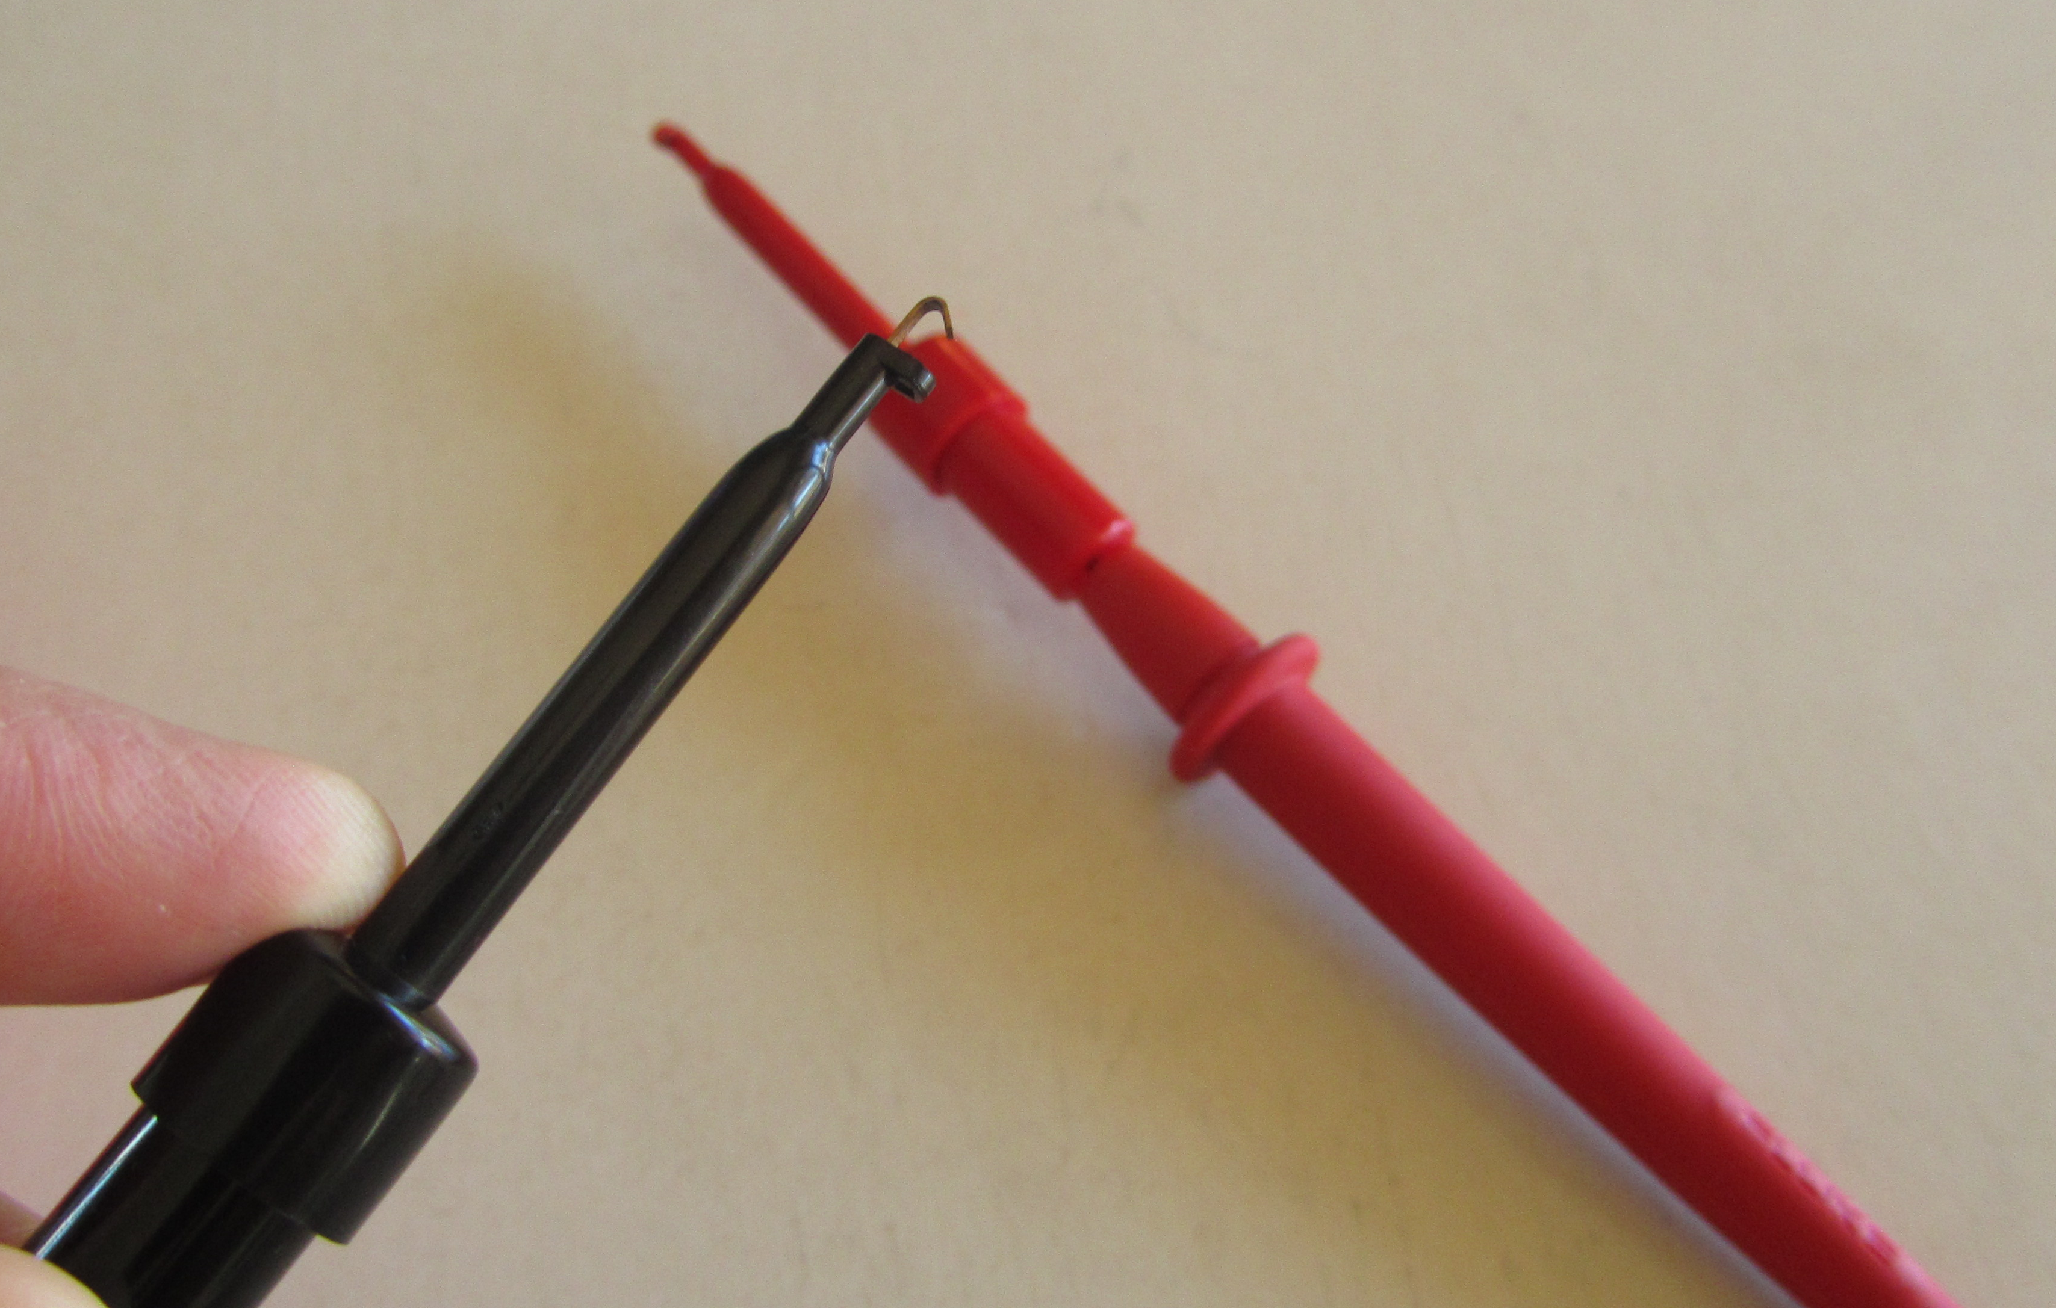

Voltmeter with mini test clips attached
Close up of mini test clips

Documentation
Write a report to include the following:
- Describe how to calculate the SPC limits, show equations and sample calculations.
- Describe which type of SPC chart you used for the individual measurements in your batch and show this chart with its control limits and the data points from your individual measurements from your batch.
- Describe which Shewhart rules you applied to your individual measurements chart.
- Discuss the variation and possible causes of variation between individual rod measurements in each given batch.
- Describe which SPC chart(s) you used for the classroom batch measurements.
- Describe which Shewhart rules you applied to your classroom measurements chart.
- Discuss possible causes of variation between the batch measurements in the classroom.
- Discuss the differences between your SPC chart for individual rod measurements, and the X-bar chart for the classroom batch measurements. Which one is more accurate?
- Describe what additional information the Range chart for the classroom batches gives you and how the X-bar and Range chart can work together.
- Answers to the Post-Activity questions.

Expectations
This activity allows you to put into practice the concepts of Statistical Process Control (SPC) by taking you through the steps of building a SPC chart. You measure and plot resistance values on your SPC chart and use the Shewart/Western Electric Rules to determine if your process is in control. This exercise also helps you to gain insight into causes of process variation.

Preparation / Setup
Gather all of the supplies for this activity. Set up a workspace on a flat table large enough to lay out each piece of lead in your batch. Keep in mind that you will be using a voltmeter to measure the resistance of each graphene rod. You will also need to keep track of the order of each piece of rod that you measure; therefore, consider that when you are setting up your workspace.

Activity: Part I – Calculate the individual SPC chart parameters using historical data & create an SPC Chart with Control Limits

- You are given a sample set of historical resistance measurement data for 20 different batches of 6 cm long conductive, graphene rods. This data for each batch (x_{n}) is actually the mean or $\overline{X}$ (X-bar) of the individual resistance measurements of each individual rod in a batch.

Historical Mean Resistance values ($\overline{X}$) for 20 different batches of 6mm graphene rods.

$$\overline{X}=x_{n}$$
Resistance (Ω)
1.6
1.6
1.7
1.4
1.9
1.6
1.9
1.4
1.6
1.7
2.0
1.3
2.0
1.8
1.7
2.0
1.6
1.4
1.7
1.9

- Use this set of historical $\overline{X}$ (X-bar) data given above to calculate the mean of the batch means or $\overset{̿}{X}$(X-bar-bar). This will be the centerline or target value for your SPC chart. We will call this $\overset{̿}{X}$value, μ. Recall the equation for μ:

$$μ=\frac{Σx_{n}}{n}$$

- Use this set of historical $\overline{X}$ data and the $\overset{̿}{X}$you have just calculated to calculate the standard deviation for your historical data. Recall the equation for standard deviation, σ:

$$σ=\sqrt{σ^{2}}=\sqrt{\frac{\sum_{i=1}^{n}{{(x_{i}-μ)}^{2}}}{n-1}}$$

$x_{i}= \overline{X} and μ= \overset{̿}{X}$

- Use the mean of the batch means or $\overset{̿}{X}$value and the standard deviation value to find the control limits: μ±1σ, μ±2σ, and μ±3σ.

- Using the SPC chart template on the following page, set up your SPC chart by plotting your calculated values: $\overset{̿}{X},$μ±1σ, μ±2σ, and μ±3σ. Make sure to label the chart values and remember, these 7 values should be shown as Control Limits, or lines across your chart. It is a good idea to use colors to distinguish between $\overset{̿}{X},$μ±1σ, μ±2σ, and μ±3σ.

Mean (μ)  $$\overset{̿}{X}$$ | Std. Dev. (σ) | μ+1σ | μ-1σ | μ+2σ | μ-2σ | μ+3σ | μ-3σ

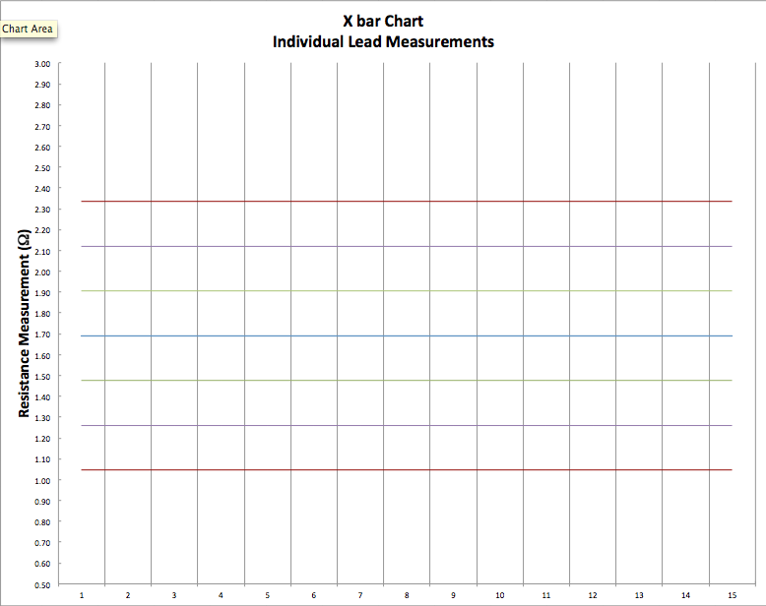
Part II – Use your given batch of lead to measure the resistance of each individual lead

- Using the voltmeter, measure the resistance value (in Ω) of each individual piece of lead in your batch.
  - Make sure that the voltmeter is set to measure Ω.
  - Attach the mini test clips to the probes. Be very careful when attaching and detaching these mini test clips from the probes. They break easily.
  - Attach a mini test clip to each end of the graphene rod. Be careful when attaching the clips to each end, you don’t want to snap off the end of the rod.

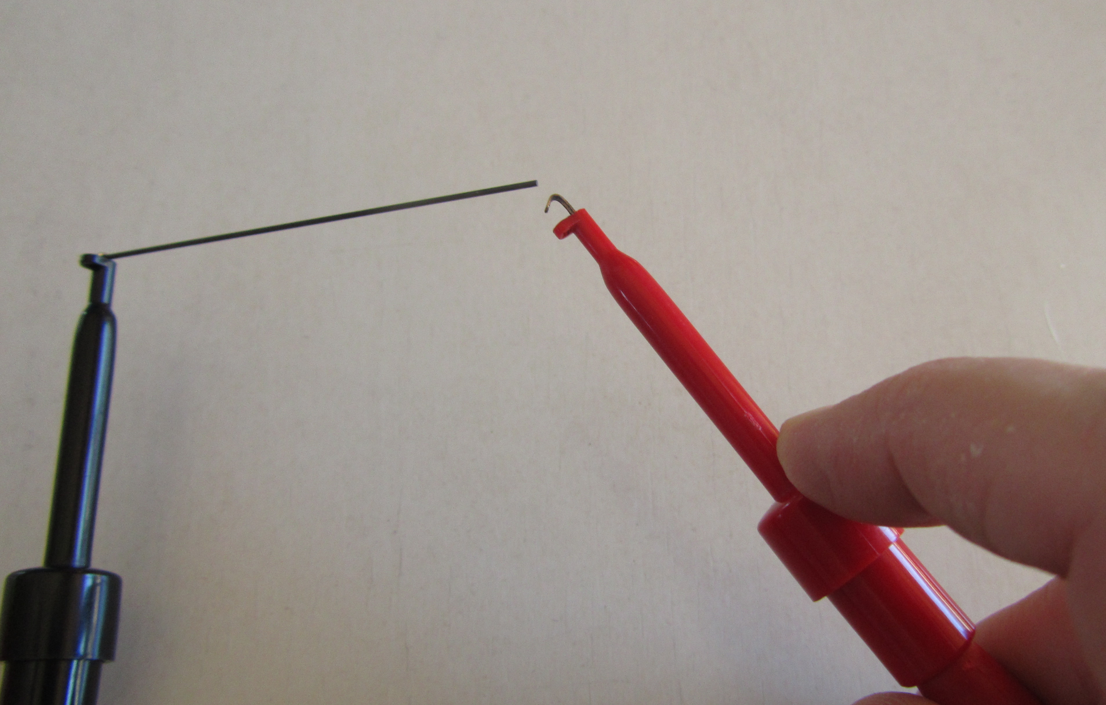

  - Once both mini test clips are attached, place the clips with the rod flat on the table and let the voltmeter reading stabilize.

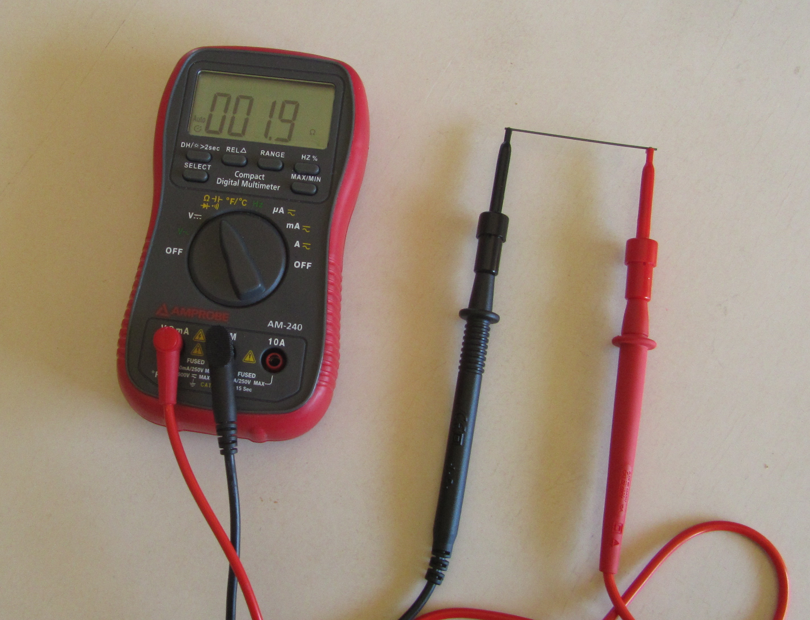

  - Record the resistance value in the table on the following page.
  - Repeat for each of the 15 rods in your batch.

Measured Data
Resistance (Ω) Individual lead

Part III – Plot the individual resistance values on the SPC Chart.

- Plot the resistance value of each individual measurement on your SPC chart you created in Part I.
- Using the Shewhart/Western Electric Rules, are these resistance measurements “in control”.
- Do you notice any process changes such as shifting, trending, cycling?

8 Rules to Signal an Out of Control Process – Shewhart Rules or Western Electric Rules

Rule 1: A single point outside the μ±3σ zone.
Rule 2: 2 out of 3 successive points outside μ±2σ zone.
Rule 3: 4 out of 5 successive points outside μ±1σ zone.
Rule 4: 8 or more successive numbers either strictly above or strictly below the mean (the center).
Rule 5: 6 or more successive numbers showing a continuous increase or continuous decrease.
Rule 6: 14 or more successive numbers that oscillate in size (i.e. smaller, larger, smaller, larger)
Rule 7: 8 or more successive numbers that avoid μ±1σ zone.
Rule 8: 15 successive points fall into μ±1σ zone only, to either side of the centerline.

Part IV – Set up and create a X-bar Chart for the classroom batches

- Using the X-bar chart for batch resistance values on the following page, plot the control limits, $\overset{̿}{X},$μ±1σ, μ±2σ, and μ±3σ, that you calculated in Part I.
- Calculate X-bar (mean) for your batch of rods.
- Plot the X-bar resistance value for your batch on the X-bar SPC chart on the following page.
- Calculate the Range for your batch of rods.
- Given the Range Chart for Batch Resistance values, plot your batch range of resistance on the Range SPC chart.
- If there are other groups in your class calculating the X-bar and Range for their batches, record their $\overline{X}$ and R values and plot them on your X-bar and R charts. If there are not other groups, obtain X-bar and R values from your instructor to plot on your X-bar and R charts.
- Using the Shewhart/Western Electric Rules, are your plotted resistance measurements “in control”.
- Compare the X-bar and R charts, what do you notice?
- Compare the Individual Measurements Chart you created in Part III to the X-bar chart of batch values created here, what are the differences?

Your Batch Mean and Range Values

Batch Mean  $$\overline{X}$$ | Range

Other Class Batch Mean and Range Values

Batch Mean  $$\overline{X}$$ | Range

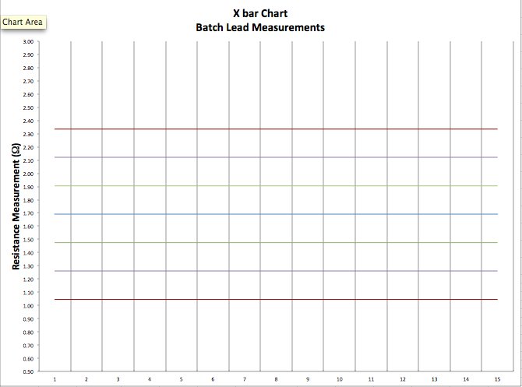

Post Activity Questions

- Discuss the possible causes of variation in measurements within each batch.

- Discuss the possible causes of variation between the X-bar values for each batch in the classroom.

- Compare the Individual Measurements Chart you created in Part III to the X-bar chart of batch values created here. What are the differences?

- Discuss the difference between the X-bar, and R charts, what do you notice?

Support for this work was provided by the National Science Foundation's Advanced Technological Education (ATE) Program through Grants. For more learning modules related to microtechnology, visit the SCME website (http://scme-nm.org).

