Statistical Process Control Assessment
Participant Guide

SPC Final Assessment
This Assessment determines analyzes your understanding of Statistical Process Control and how it relates to MEMS fabrication after having completed the SPC learning module and its related activities.
There are 12 assessment questions below. Answer each to the best of your knowledge.

- What are the two types of variation found in a manufacturing process?

- Explain why understanding variation is particularly important in MEMS manufacturing.

- What are important factors in process control? (mark all that apply)
  - Communication between operators, technicians, engineers, & management
  - Plenty of historical data to set up your control chart
  - Knowledge of Design of Experiments
  - Eliminating process variation

- Summarize the benefits and uses of Statistical Process Control.

- Given the following set of data, calculate the Centerline Value of a X-bar Chart.
5.5, 7, 7.25, 4.9, 6.32, 5.74

- Using the data set above, calculate Upper Control Limit

- Fill in the blank: The control limits are based upon the assumption that the historical data is distributed ________________________.

- Is the following process “in control”? If not, state the rule that supports your answer.

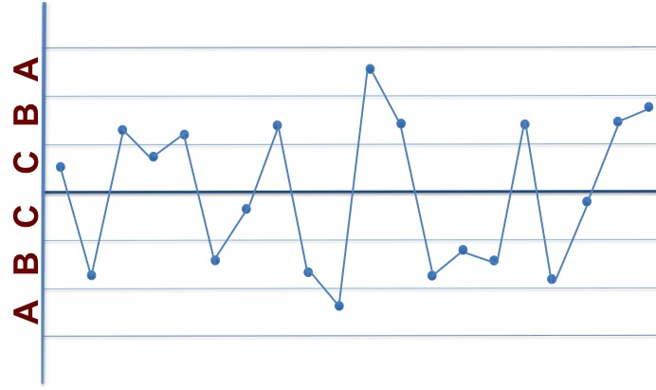

- Is this process in Control? If not, state the rule that supports your answer.

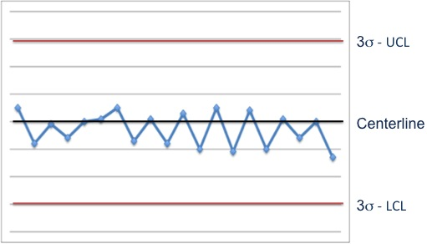

- What do you do when your process is out of control or is experiencing a trend, cycle, or shift?

- Explain what is happening with the process if your process is violating Rule 8 of the Shewhart Rules.

- What is the difference between specification limits and control limits?

