NFPA Diamond Interpretation Activity
Participant Guide

Description and Estimated Time to Complete

This activity provides practice exercises for interpreting the NFPA (National Fire Protection Association) diamond ratings. When entering a microsystems fabrication facility is it important that you can quickly identify stations with hazards materials and state the type of hazards associated with each material. This activity will provide you the opportunity to demonstrate your ability to perform this task.

Estimated Time to Complete
Allow 30 minutes to complete this activity.

Introduction

The NFPA diamond was developed by the U.S. National Fire Protection Association. It is used by emergency personal, employees, students and the general public to quickly identify the potential hazards of a chemical. The diamond can be found throughout a microsystems fabrication facility.

Each section (color) of the diamond indicates the “level” of a specific hazard: 0 being “least severe hazard” and 4 being “most severe hazard”. Below are the types of hazards displayed on a NFPA diamond and the “level of hazard”.

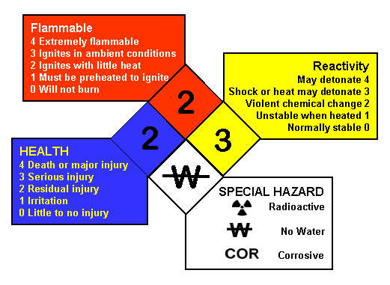

NFPA Locations

Examples of where one might see a NFPA diamond:

- 18-wheeler transporting a chemical
- Compressed gas cylinders
- Doors to storage rooms
- Entry doors to manufacturing facilities
- Chemical labels on bottles and crates

Activity Objectives and Outcomes

Activity Objectives
- Correctly interpret at least three NFPA diamonds
- Match NFPA diamonds to specific chemicals

Activity Outcomes

Correct interpretation of a NFPA diamond requires that you are able to state the level of hazard for flammability, health and reactivity, and to describe what each level means based on the chemical's characteristics. You should also be able to identify any special hazards or PPE (Personal Protective Equipment) required as specified on the NFPA diamond and/or the MSDS.

Resources

NFPA Ratings Interpretation Unit
Internet access for "Research" assignment

Documentation

- Complete the table according to the activity’ instructions.
- Answers to Post- Activity questions.

NFPA Rating Interpretation Activity

Below is a list of chemicals. On the following page is a chart with nine NFPA diamonds. For each NFPA diamond,
- match it to at least one of the listed chemicals using the information found on the chemicals’ MSDSs,
- describe what each hazard level or symbol means, and
- provide the information from the MSDS that supports that hazard and hazard level.

CHEMICALS

- Ammonia
- Carbon Dioxide
- Ethylene Glycol
- Gasoline – Unleaded
- Hexamethyldisilazane (HMDS)
- Hydrofluoric Acid
- Hydrogen Peroxide
- Isopropyl Alcohol
- Nitrogen Dioxide
- Nitrogen Gas
- Photoresist
- Silane Gas
- Sodium Hydroxide (Drano)
- Sulfuric Acid
- Water

NFPA Diamond | Chemical(s) | Describe each rating | Support each rating with information from the chemical’s MSDS
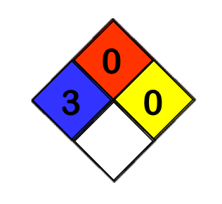
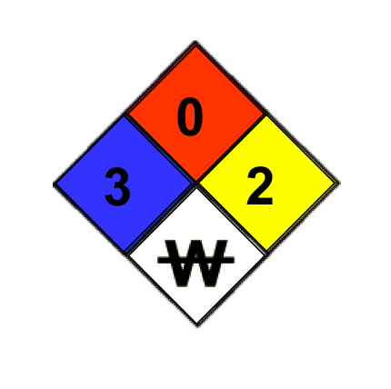
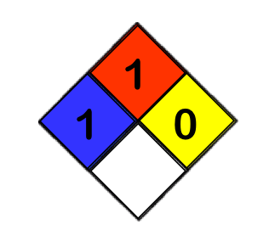
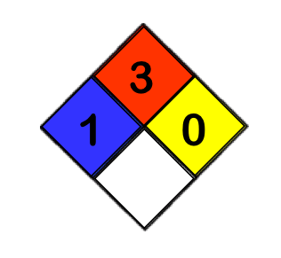
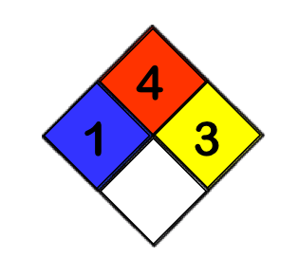
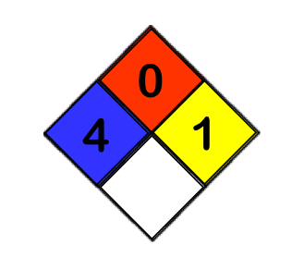
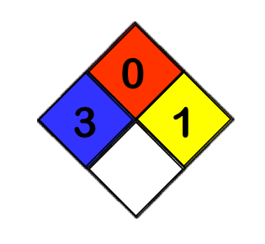
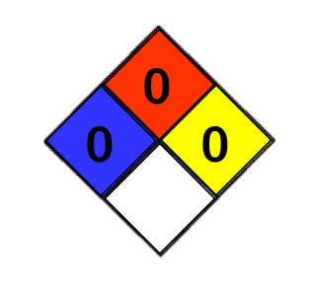
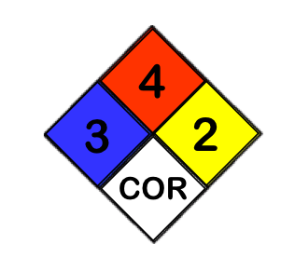

Post-Activity Questions

- List four places where you have seen an NFPA diamond.

- What chemical property is used to determine the flammability rating?

- What property is used to determine a chemical's reactivity rating?

- List at least four special hazards or warnings that one might find in the white section of the NFPA diamond. Include the symbol used to indicate each special hazard.

- Based on the NFPA ratings for sodium hydroxide (Drano®), what precautions should you take when working with or around this chemical?

- Based on the NFPA ratings for sulfuric acid, what precautions should you take when working with or around this chemical?

Disclaimer

The information contained herein is considered to be true and accurate; however the Southwest Center for Microsystems Education (SCME) makes no guarantees concerning the authenticity of any statement. SCME accepts no liability for the content of this unit, or for the consequences of any actions taken on the basis of the information provided.

Support for this work was provided by the National Science Foundation's Advanced Technological Education (ATE) Program. For more learning modules on safety and microtechnology, please visit the SCME website (http://scme-nm.org).

