Interpreting NFPA in the Workplace Activity
NFPA: National Fire Protection Association

Participant Guide

Description and Estimated Time to Complete
This activity requires you to identify places where NFPA (National Fire Protection Association) diamonds are used. It also requires you to interpret NFPA diamonds in the workplace. Before starting this activity, review the NFPA Rating / NFPA Diamond instructional unit (PK) that explains the NFPA diamond and its components.

When entering a microsystems fabrication facility is it important that you can quickly identify stations with hazardous materials and state the type of hazards associated with each material. This activity provides you the opportunity to demonstrate your ability to perform this task.

- This activity requires a lab or manufacturing facility
- Allow 30 minutes to collect data and another 30 minutes for documentation

Introduction
The NFPA diamond was developed by the U.S. National Fire Protection Association. It is used by emergency personal, employees, students and the general public to quickly identify the potential hazards of a chemical. The diamond can be found throughout a microsystems fabrication facility.

Activity Objectives
Activity Objectives
- State four locations where a NFPA diamond is used within a laboratory or manufacturing facility
- Correctly interpret at least four NFPA diamonds in the workplace

Safety
NFPA diamonds are located in areas where potential hazards exist.

Follow the safety rules and wear the appropriate PPE (Personal Protective Equipment) of the lab / facility when locating NFPA diamonds.

Do NOT touch the cylinders or bottles.

Attitude & Behavior
Chemicals are dangerous and can cause serious harm or even death if handled improperly!

When working in a lab or manufacturing facility, practice all the safety rules of the facility and for being around hazardous chemicals and situations.
Team
Always Work with a Buddy!

Use the buddy system when locating NFPA diamonds in the lab or fabrication facility.

Dependencies
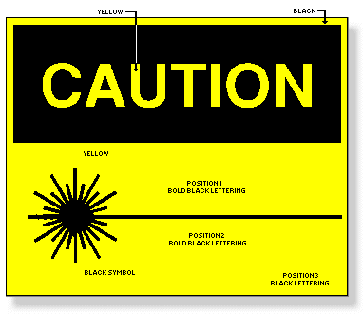
Hazards Warning

Before starting this activity, you should know the safety rules of the facility and should be familiar with the location and potential hazards of all of the chemicals and other hazards in the facility.

Facilities
This activity requires an environment with properly labeled chemical bottles and compressed gas cylinders, storage cabinets and rooms. The facility for this activity must have at least five NFPA diamond properly displayed.
Supplies
Appropriate attire and PPE for the facility, and cleanroom paper (if required)

Resources
NFPA Ratings Interpretation Unit

Documentation
Complete the table at this end of this activity using the required information collected the facility and from related Safety Data Sheets (SDSs) .

Interpreting NFPA Diamonds in the Workplace Activity

Identify common locations for NFPA diamonds in a laboratory environment and interpret each NFPA diamond you locate.

- If this activity is to be completed in a cleanroom environment, you will need a cleanroom notebook and pen to take notes.
- Before entering, review the safety rules of the lab of facility.
- Gown in the attire required of the facility when applicable.
- While completing this activity, wear all required PPE.
- Locate at least four (4) NFPS diamonds in this facility.
- For each NFPA diamond, document the location of the diamond, the information on the diamond, the chemical's name, and other chemical characteristics that are used to justify the NFPA ratings.
- Transfer the information collected into the table at the end of this activity.
- Interpret the information for each NFPA diamond. Use the chemical's characteristics and properties to justify the rating for each NFPA category. You may need to refer to the chemical's SDS.

Chemical Name | Location | NFPA Categories/Ratings | Special Hazards | SDS supporting information

Support for this work was provided by the National Science Foundation's Advanced Technological Education (ATE) Program.

