Interpreting Chemical Labels
Final Assessment
Participant Guide
The objective of this assessment is to determine your current knowledge on the requirements of chemical labels, NFPA ratings for chemical hazards and the ratings interpretation.

Answer each of the following assessment questions.

- What United States organization sets the requirements for the information found on chemical labels?
  - National Fire Protection Association
  - Occupational Safety and Health Association
  - National Safety Council
  - American Society of Safety Engineers

- Which of the following items is NOT required on the label of chemicals shipped from the manufacturer?
  - Emergency contact number
  - NFPA Fire Diamond
  - Chemical Identity
  - Physical / Health Hazards

- Which of the following is NOT required on a chemical label to provide a warning of a health or physical hazard?
  - Hazard pictogram
  - Single Word
  - Hazard of precautionary statement
  - SDS identification number

- The buyer of a chemical is allowed to transfer small amounts of the chemical into supplementary bottles. Which of the following is required on the labels for such bottles?
  - NFPA diamond and chemical identity
  - Chemical identity and emergency contact number
  - Chemical identity and appropriate hazard warning (word/pictogram)
  - Chemical identify and manufacturer’s information

- On a NFPA diamond, the color blue represents which category?
  - Health
  - Flammability
  - Reactivity
  - Special Hazard

- On a NFPA diamond, the color yellow represents which category?
  - Health
  - Flammability
  - Reactivity
  - Special Hazard

- Which of the following BEST describes the health hazard indicated in the following NFPA diamond?
  - Extreme Danger
  - Prolonged exposure could cause residual injury
  - Hazard no greater than ordinary material
  - Hazardous

- Which of the following BEST describes the flammability hazard indicated in this NFPA diamond?
  - Extremely flammable
  - Must be preheated for ignition
  - Has a flashpoint below 100° F
  - Has a flashpoint below 200° F

- In this NFPA diamond, the chemical is classified as a __________.
  - Oxidizer
  - Flammable
  - Carcinogen
  - Corrosive

- What is wrong with the information on the following NFPA diamond?
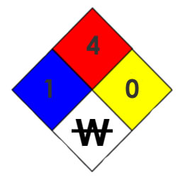
  - A flammability rating of 4 requires a higher health hazard rating.
  - Do no mix with water requires a higher reactivity hazard rating.
  - Do not mix with water requires a higher health hazard rating.
  - There is nothing wrong with the information on this NFPA diamond.

- On a NFPA diamond a reactivity rating of 3 implies the following.
  - Normally stable
  - May detonate
  - Violent chemical change
  - Shock or heat may detonate
  - Unstable when heated

- Which of the following NFPA diamonds BEST represents the characteristics of the Industrial Bowl Cleaner chemical described in the label below?

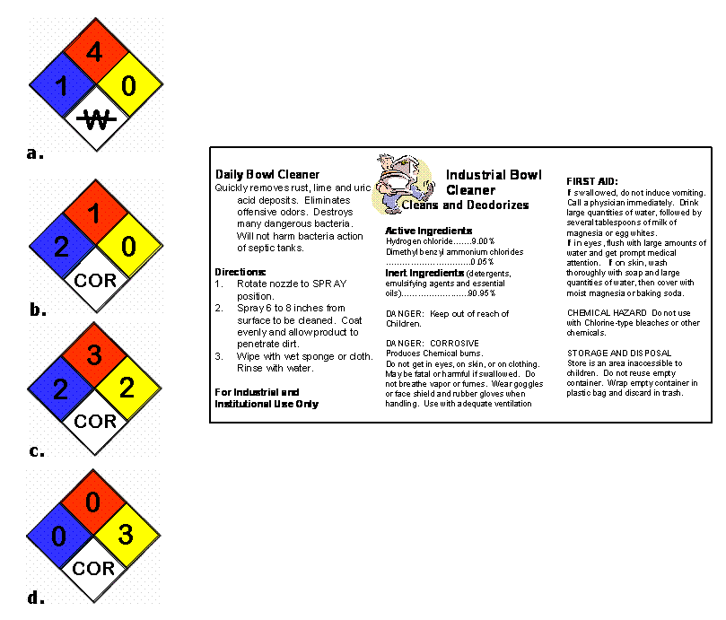

Support for this work was provided by the National Science Foundation's Advanced Technological Education (ATE) Program.

