Interpreting Chemical Labels
Primary Knowledge
Participant Guide

Description and Estimated Time
The purpose of this learning module is to provide you with the information needed to interpret chemical labels and information about specific chemicals provided on NFPA diamonds and to demonstrate an understanding of this information.

Just like any chemical cleaner you buy at the store, each chemical used in the fabrication of microsystems has a label that contains important information about that chemical. Before using any chemical, READ THE LABEL. This unit provides information on the content and requirements of chemical labels. This information is needed to successfully engage in the activity that is relevant to chemical labels, their content, and interpretation.

Estimated time to complete:

Allow at least 10 minutes

Introduction
When working with a chemical, the most accessible information is the information on the chemical bottle's label. The label tells you what the chemical is and any immediate hazards associated with the chemical. Once you know what you are dealing with, you should consult the SDS (Safety Data Sheet) for additional information.

OSHA (Occupational Safety and Health Association) requires that all in-plant / in-lab containers of chemicals be labeled, tagged, or marked with the chemical’s identity and appropriate hazard warnings. This includes secondary containers as well as primary containers.
Learning Module Objectives

- Be able to interpret the information on at least 3 chemical bottles.
- Be able to interpret the information on NFPA (National Fire Protection Association) diamonds.
- State at least three chemical safety rules related to the information found on a chemical label.
Safety
Chemicals are dangerous and can cause serious injury or death when handled improperly. One should always read the label and study the Safety Data Sheet (SDS) prior to using, handling, or working with a chemical.
Dependencies
Knowledge of the terminology associated with hazardous materials and their properties would complement the information presented in this unit. See SCME's Hazardous Materials I and II.
Key Terms
Chemical labels
NFPA (National Fire Protection Association)
OSHA (Occupational Safety and Health Association)

OSHA Requirement
OSHA requires that chemical manufacturers and distributors label every container of hazardous chemicals that they ship.

Label requirements are stated in the Hazardous Communication Standard (HCS) (110.1200). The following was extracted from U.S. Department of Labor OSHA – HCS website (https://www.osha.gov/dsg/hazcom/hazcom-faq.html).
“Under the current Hazard Communication Standard (HCS), the label preparer must provide the identity of the chemical, and the appropriate hazard warnings. This may be done in a variety of ways, and the method to convey the information is left to the preparer. Under the revised HCS, once the hazard classification is completed, the standard specifies what information is to be provided for each hazard class and category. Labels will require the following elements:
- Pictogram: a symbol plus other graphic elements, such as a border, background pattern, or color that is intended to convey specific information about the hazards of a chemical. Each pictogram consists of a different symbol on a white background within a red square frame set on a point (i.e. a red diamond). There are nine pictograms under the GHS. However, only eight pictograms are required under the HCS.
- Signal words: a single word used to indicate the relative level of severity of hazard and alert the reader to a potential hazard on the label. The signal words used are "danger" and "warning." "Danger" is used for the more severe hazards, while "warning" is used for less severe hazards.
- Hazard Statement: a statement assigned to a hazard class and category that describes the nature of the hazard(s) of a chemical, including, where appropriate, the degree of hazard.
- Precautionary Statement: a phrase that describes recommended measures to be taken to minimize or prevent adverse effects resulting from exposure to a hazardous chemical, or improper storage or handling of a hazardous chemical."

These requirements are reviewed in this lesson.
Label Contents¹
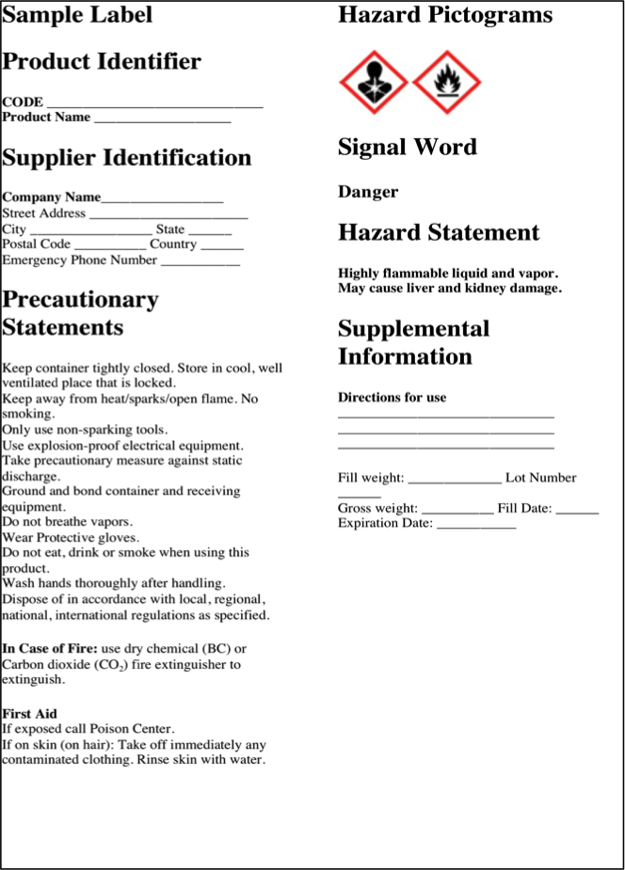
When a chemical is shipped from the manufacturer or importer, the chemical's label must contain, at a minimum, the following information:

- Product Identifier – Code and product name
- Supplier Identification – name and address and emergency phone number
- Hazard Pictograms
- A Single Word (e.g., Danger, Corrosive, Oxidizer)
- Hazard and Precautionary Statements

The manufacturer's label must remain on the container once received by the customer.

For more detailed information about chemical label requirements and to study examples of “acceptable” labels, read the OSHA Brief “Hazard Communication Standard: Labels and Pictograms” (https://www.osha.gov/Publications/OSHA3636.pdf ).
Labels for Secondary Containers
If the chemical is transferred to another container, the customer must properly label the new container. All in-plant / in-lab containers of hazardous chemicals must be labeled, tagged, or marked with the following²:

- Chemical’s identity
- Appropriate hazard warnings (physical and health hazards)

Modified Label for Secondary Container

Hazard Warnings
The hazard warning is a brief statement, word, picture, symbol or combination thereof that quickly and clearly states the chemical’s immediate hazard(s). Below are commonly used warnings:

- Flammable
- Corrosive
- Causes lung damage
- Poisonous if swallowed
- Do not mix with water

Standard symbols have been created to represent hazards such as corrosive, flammable, oxidizer and poison.

What other hazard warning symbols would you recognize (in addition to the ones shown here)?
The NFPA Diamond (National Fire Protection Association)
A quick and easy way to supply the user with critical information about a chemical is the NFPA diamond. The NFPA diamond uses a system of ratings developed by the National Fire Protection Association. These ratings inform the user of a chemical's level of hazard in health, flammability and reactivity. It also warns of any special hazard such as "do not mix with water" or "corrosive".
To learn more about the NFPA ratings and how to quickly interpret a NFPA diamond, see SCME's unit on the NFPA Ratings / NFPA Diamond.

ANSI Requirements
Additional information may be included but is not required by OSHA. However, many manufacturers use a voluntary labeling standard published by the American National Standard Institute (ANSI Z129.1-1988). This standard calls for the following items in addition to those required by OSHA:

- Signal words - DANGER, WARNING, CAUTION
- Highly toxic materials shall be marked POISON
- Precautionary measures useful in preventing physical harm to the individual
- Instructions in case of exposure
- Notes to physician for emergency treatment
- Instructions in case of fire or chemical spill
- Instructions for chemical handling and storage

Rules for Chemical Labels
- Read all labels carefully.

- Double-check the label. Know what you are handling.

- Do NOT use a chemical if it is unfamiliar to you or it has no label.

- Ensure the chemical container has the proper label.

- Chemical labels must be legible and prominently displayed.

- Chemicals poured into a smaller container for daily use must be properly labeled.

- Never obscure, deface, or remove any label.

Summary
The chemical label is an immediate warning that a chemical may pose a physical or health hazard to the user. Therefore, it is important that one be able to quickly interpret the information on a chemical label and know when additional information should be acquired.

Additional information about a chemical can be found in its Safety Data Sheet (SDS).
Related SCME Learning Modules
The following learning modules can be downloaded from the SCME website (http://scme-nm.org).

Hazardous Materials Learning Module
Chemical Lab Safety Rules
Material Safety Data Sheets (SDS)
SDS Activity
NFPA Ratings / NFPA Diamond

Disclaimer
The information contained herein is considered to be true and accurate; however the Southwest Center for Microsystems Education (SCME) makes no guarantees concerning the authenticity of any statement. SCME accepts no liability for the content of this unit, or for the consequences of any actions taken on the basis of the information provided.
Support for this work was provided by the National Science Foundation's Advanced Technological Education (ATE) Program.

