NFPA Ratings / NFPA Diamond
(NFPA – National Fire Protection Association)

Participant Guide

Description and Estimated Time to Complete
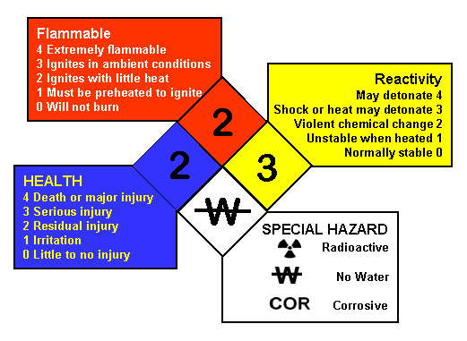
NFPA Ratings / Diamond
This unit provides content information about the NFPA (National Fire Protection Association) ratings and related NFPA diamond. By the end of this unit you will be able to interpret NFPA diamonds and relate specific chemicals to NFPA hazard types and levels. This information will prepare you to quickly identify the potential dangers associated with chemicals used in microsystems fabrication.

Estimated time to complete:
Allow 15 minutes

Introduction
When working with a chemical, the first information that one usually sees is the information on the chemical’s label. The purpose of this information is to warn you of the hazards associated with the chemical. Once warned, you should consult the MSDS (Material Safety Data Sheet) for additional information.

OSHA (Occupational Safety and Health Association) requires that all in-plant / in-lab containers of chemicals be labeled, tagged, or marked with the chemical’s identity and potential hazards. One instrument commonly used to identify a chemical’s potential hazards is the National Fire Protection Association (NFPA) Diamond.

NFPA Diamond
Dependencies
Prior knowledge of the terminology associated with hazardous materials would be beneficial.
See SCME Hazardous Materials I and II.

NFPA Standard
The NFPA ratings were developed by the U.S. National Fire Protection Association. The NFPA diamond is a pictorial representation of these ratings as defined in the NFPA 704 standard. The NFPA diamond is sometimes referred to as the "fire diamond". It is used by emergency personal, employees, students, and the general public to quickly identify the potential hazards of a chemical.

Examples of where one might see a NFPA diamond:
- 18-wheeler transporting a chemical
- Compressed gas cylinders
- Doors to storage rooms
- Entry doors to manufacturing facilities
- Chemical labels on bottles and crates

NFPA Hazard Warnings
In a NFPA diamond, each smaller diamond represents a particular hazard. The hazards shown are
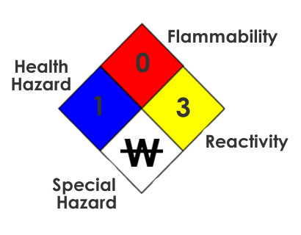
- Flammability (red),
- Health Hazard (blue),
- Reactivity (yellow), and
- Special (white).

The number within each diamond represents the "level" of the hazard.

NFPA Ratings
NFPA Ratings
The level of each hazard represented by a NFPA diamond is given a 0 to 4 rating:

0 = "least severe hazard"

4 = "most severe hazard"

Each level represents a specific degree of hazard depending on the category. Some sections, such as Flammability, are well defined and based on a chemical’s flashpoint. However, the Health rating can be somewhat subjective. This could be dependent upon the manufacturer’s interpretation of the MSDS and the concentration of a chemical. At times you might see different levels for the same chemical. Let’s look into each section in more detail.

RED: Flammability Ratings
The level of hazard is based on the chemical’s flashpoint.

4 – Extremely flammable.
Will vaporize at normal pressure and normal temperature
[Flashpoint below 73°F (23°C)]

3 – Ignition may occur under most ambient conditions
[Flashpoint below 100°F (38°C)]

2 – Must be moderately heated for ignition
[Flashpoint below 200°F (93°C)]

1 – Must be preheated for ignition
[Flashpoint above 200°F (93°C)]

0 - Will not burn

BLUE: Health Hazard Ratings
4 – Deadly: Exposure may cause death or major residual injury

3 – Extreme Danger: Exposure could cause serious injury even if treated

2 – Hazardous: Intense or prolonged exposure may cause incapacitation or possible residual injury

1 – Slightly Hazardous: May cause irritation or minimal residual injury

0 – Normal Material: Hazard no greater than ordinary material

YELLOW: Reactivity Ratings
4 – Can detonate at normal temperatures or pressures

3 – Can detonate with shock or strong ignition source, or reacts explosively with water

2 – Unstable. Can undergo violent chemical change at elevated temperatures or pressures. Capable of reacting violently or forming explosive mixtures with water.

1 – Normally stable, but can become unstable at elevated temperatures and pressures. May react with water, but not violently.

0 – Stable. Not reactive with water.

WHITE: Special Hazard / PPE
Specific symbols are used to indicate hazards such as
- Reacts with water
- Strong Oxidizer
- Corrosive
- Radioactive
- Poison

White is also used to indicate if specific personal protective equipment (PPE) is required:
- goggles
- acid gear
- respirator

Special Hazards
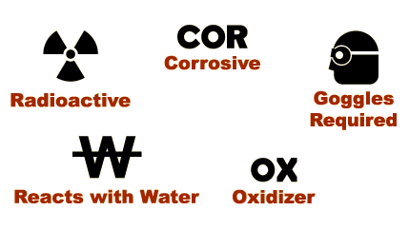
These are some of the symbols used in the WHITE of a NFPA diamond.

Let's check your understanding of the rating levels.

What flammability rating would be given to a chemical that may ignite under most ambient conditions and has a flashpoint less than 100 F?

What health rating would a chemical have that may cause irritation or minimal residual injury?

What reactivity rating would a chemical have that was capable of reacting violently or forming explosive mixtures with water?

What does COR in the White diamond represent? _________________________

Which of the following would one NOT find in the white section of a NFPA diamond?
- COR
- Goggles required
- OX
- Reacts with bleach
Which of the following is NOT true in reference to the NFPA diamond?
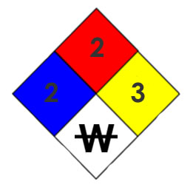
- Prolonged exposure may cause incapacitation
- Flashpoint is less than 200 F
- Can detonate at normal temperature and pressure
- Do not mix with water

Summary
The NFPA diamond is a reliable warning symbol used on labels, doors, compressed gas cylinders, and other chemical storage devices. Variations of this diamond are found throughout laboratories, manufacturing facilities, and microsystems fabrication facilities.

It is important to be able to interpret the information provided in a NFPA diamond.
Food for Thought
What are ways to remember the colors and their respective warning (health, fire, reactivity or special)?

Develop a formula or system for associating the level's flashpoint temperature with its rating.

Develop a formula or system for associating the level's health or reactivity rating.
References
1. OSHA (https://www.osha.gov/)
2. National Fire Protection Association (http://www.nfpa.org/)
3. The MSDS HyperGlossary (http://www.ilpi.com/msds/ref/index.html )
Related SCME Learning Modules and Units
The following learning modules can be downloaded from the SCME website (http://scme-nm.org).
- Hazardous Materials Learning Module
- Material Safety Data Sheet Learning Module
- Chemical Labels
- NFPA Ratings Interpretation Activity
Disclaimer
The information contained herein is considered to be true and accurate; however the Southwest Center for Microsystems Education (SCME) makes no guarantees concerning the authenticity of any statement. SCME accepts no liability for the content of this unit, or for the consequences of any actions taken on the basis of the information provided.
Support for this work was provided by the National Science Foundation's Advanced Technological Education (ATE) Program.

