Hazardous Materials II

Primary Knowledge
Participant Guide

Description and Estimated Time
This Hazardous Materials II unit provides information needed to safely work with and around hazardous materials used in microtechnology fabrication facilities and other manufacturing facilities.

Hazardous Materials II covers the characteristics of chemicals that are health hazards. It also covers how chemicals can enter the body and what one can do to prevent toxic exposure.

Hazardous Materials (HazMat) I, the first lesson of this learning module, provides information on the federal regulations for HazMat training and discusses the characteristics of chemicals that create physical hazards for the environment and the people working in that environment.

Estimated Time to Complete HazMat II
Allow at least 20 minutes.

Introduction
Chemicals pose a wide range of health hazards. Hazardous Materials II discusses the characteristics of chemicals that establish them as health hazards and the characteristics for establishing the toxicity of a chemical. It should precede all activities in which one is required to handle, work with or around chemicals.

Health hazards are associated with any chemical that may produce acute or chronic health effects to humans through exposure.
Some chemical require protective
gear such as seen in this picture.
This person is working with an acid and
is dressed in appropriate acid gear.
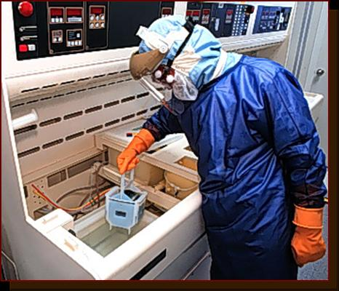
[Photo courtesy of Bob Willis]

Learning Module Objectives
- Describe at least five characteristics of chemicals that are physical hazards.
- Describe at last five characteristics of chemicals that are considered health hazards.
- Match the physical and health hazards to their warning symbols.

Key Terms (These terms are defined in this unit)
corrosive
dose
flammable
SDS
oxidizer
PEL
poison
toxicity
TLV

Chemical Characteristics of Health Hazards

Below are chemical characteristics that are considered health hazards. The graphic illustrates the standard warning symbols for biohazards, corrosives and poisons.

Asphyxiant - Vapor or gas that can cause unconsciousness or death by suffocation.

Biohazard - Biological substance that poses a threat to human health, such as medical waste, samples of a microorganism, virus or toxin (from a biological source).

Carcinogenic - Substance that has been proven, or is suspected, of being able to produce cancer in a human being.

Corrosive - Chemical that causes visible destruction to human skin or some metals. Damage to skin is usually irreversible, leaving scars. Corrosives can be acids or bases.

Irritant - Chemical that causes a reversible inflammatory effect on living tissue by chemical action at the site of contact.

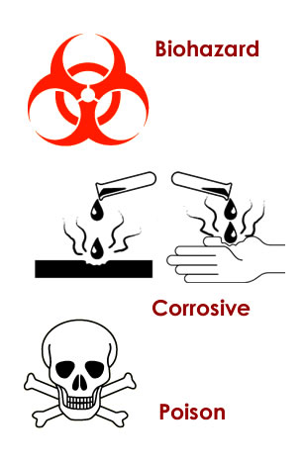
Poison - Substance that produces a toxic effect, illness or death, when ingested, inhaled or absorbed. This includes irritants that can irritate or inflame the skin, eyes or nose.

Sensitizers – Chemical that causes an allergic reaction or hypersensitivity to normal tissue of a substantial proportion of humans after repeated exposure. (e.g., pollen)

Additional Health Hazards

The following chemicals can cause damage to specific organs or a fetus.
Hepatotoxins - Toxin that can have damaging effects on the liver.

Mutagen - Chemical agent that can induce or increase frequency of mutation in an organism.

Nephrotoxins - Toxin that can have damaging effects on the kidneys.

Neurotoxins - Toxin that can damage or destroy nerve tissue.
Human Organ (Liver)
Teratogen - Substance that can cause malformation of an embryo or a fetus.

Matching Activity

Match the following chemical to the effect it can have on humans.

 |  | Chemical |  | Effect
 | 1 | Mutagen | A | Effects the liver
 | 2 | Carcinogen | B | Causes visible destruction to skin
 | 3 | Poison | C | Causes allergic reaction
 | 4 | Corrosive | D | Proven to produce cancer
 | 5 | Hepatotoxin | E | Can induce mutation in an organism
 | 6 | Sensitizer | F | Produces toxic effect when ingested

Table 1: Chemicals and Their Effects

Health Hazards Warning Symbols
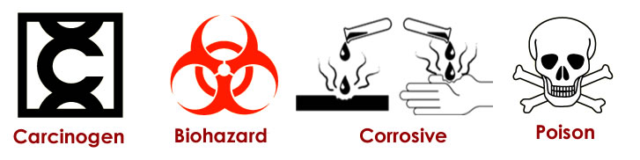
These universal symbols are used to quickly warn of potential health hazards. These symbols are found on chemical labels, compressed gas bottles, facility doors, chemical storage units, and on any object that contains a chemical that causes a specific health hazard.

Short exercise: Find at least one example of each of these health hazards.

So how does someone become exposed to a chemical?

There are three routes of exposure to a chemical:
- Inhalation - breathing through mouth or nose
- Ingestion - eating, swallowing
- Absorption - absorbing through the skin

There are two types of exposure:
- Acute - one time exposure, immediate or delayed effects
- Chronic - frequent exposures over a period of time

Health Effects of Chemicals

Certain chemical characteristics can have a mild to serious health effects on humans. Such chemicals include flammables, corrosives, oxidizers and poisons.
Corrosives
- Can cause severe and painful skin burns
- Burn the eyes and can cause blindness
- If inhaled, can burn the nose and lungs
Flammables
- Dry the skin by removing body oils
- Irritate the eyes
- If inhaled in relatively high concentration, can cause headaches, dizziness, nausea, and unconsciousness
Oxidizer
- Can cause severe and painful skin burns
- Burn the eyes and can cause blindness
- If inhaled, can burn the nose and lungs
Poison
- Can be absorbed into the body through contact with the skin
- Very irritating to the eyes
- If inhaled in relatively large amounts, can cause internal damage or even death

Matching Activity

Match the following components with their functions.

 |  | Components |  | Function
 | 1 | Acute | A | swallowing
 | 2 | Ingesting | B | Painful burns
 | 3 | Corrosives | C | Immediate effect
 | 4 | Poison | D | Enters through the nose
 | 5 | Chronic | E | Long term effect
 | 6 | Inhaling | F | Can enter through the skin
Table 2: Components and Functions

Review Question
A person develops cancer due to asbestos exposure. Is this chronic or acute exposure? _____________________________

Chemical Toxicity

A material is considered toxic or poisonous when a small amount causes harmful effects to a normal, healthy human. However, almost all materials can produce harmful effects when exposed in excessive amounts.

Toxicity is the effect a chemical has on one’s health under certain concentrations and exposure times. A chemical's toxicity level depends on
- the duration of exposure and
- the chemical's concentration.

The differentiation between a toxic substance or poison and any non-toxic substance is the dose.

Dose is the amount of material to which an organism is exposed. The greater the dose, the greater effect the exposure can have on your body. Chemicals that are considered to be toxins or poisons produce harmful effects at relatively low dosages.

The effect on humans from the same dosage or the same exposure differs from one person to another. There are many variables in determining the effect a particular chemical will have on a human:
- Race
- Variation in response among a people of the same race
- Gender
- Age
- Physiological conditioning
- State of health
- Medications, drugs, alcohol
- Heredity
- Synergistic effect
- Physical state of the chemical
- gases are inhaled rapidly
- solids are absorb slowly

Review Questions

What is an example of "different dosages" of the same chemical having "different effects" on the body?

What is an example that you have experienced in which two people had different effects from the same chemical and exposure?

Measuring Toxicity
The two common indicators for a chemical's toxicity are PEL and TLV.

Permissible Exposure Limits (PEL) – These indicators are set by Federal regulation (OSHA) for the maximum permissible concentration of a particular chemical to which one should be exposed without adverse effects. The duration of exposure and concentration of the chemical are considered in determining the PEL.

Threshold Limit Value (TLV) – This is the airborne concentration of a substance that represents conditions under which nearly all workers may be exposed day after day with no adverse effect. TLV's are advisory exposure guidelines, not legal standards. They are based on evidence from industrial experience, animal studies, or human studies when they exist. TLV's are revised yearly by the American Conference of Governmental Industrial Hygienists'.

Matching Activity

Match the following terms with their meanings.

 |  | Term |  | Meaning
 | 1 | Toxicity | A | Maximum permissible duration and concentration
 | 2 | Dose | B | Determined by duration of exposure and concentration
 | 3 | PEL | C | Permissible airborne concentration day after day
 | 4 | TLV | D | The amount of exposure
Table 3: Terms and Their Meanings

Personal Protective Equipment (PPE)
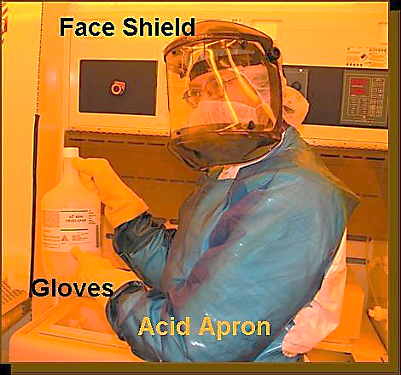
Personal protective equipment (PPE) protects the worker from chemical, physical and biological hazards that may be encountered in the workplace.

Special PPE is available for protection of the following:

Respiratory system
Several types of respirators protect from hazardous vapors / fumes and particles

Hands
A variety of different types of gloves protect from skin absorption of harmful substances, severe cuts or lacerations, severe abrasions, punctures, chemical burns, thermal burns, and harmful temperature extremes

Eyes and face
Safety glasses, goggles, face shields protect from flying particles, liquid chemicals, acids or caustic liquids, chemical gases or vapors, or potentially injurious light radiation

Feet
Special footwear protects from falling objects or chemical spills

Body
Aprons, smocks protect from acid or caustic chemical spills or splashes

Summary
In order to understand the information presented in MSDS’s and on chemical labels, one must know and understand the terminology associated with hazardous materials.

Chemicals exhibit a variety of characteristics that are considered health hazards: corrosive, carcinogen, sensitizer, irritant.

The toxicity of a chemical is based on its concentration and exposure duration.

Complete the related activities to ensure that you understand the information presented in HazMat I and II.

References
- Occupational Safety and Health Association (OSHA) (www.osha.gov)

- OSHA Hazardous Communications Standard (http://www.osha.gov/SLTC/hazardcommunications/index.html)

- The Safety Data Sheet (SDS) HyperGlossary (http://www.ilpi.com/msds/ref/index.html)

- Understanding Toxic Substances (http://www.dhs.ca.gov/ohb/hesis/uts.htm)

Related SCME Lessons
All of these learning modules and learning modules related to microtechnology can be downloaded from the SCME website (http://scme-nm.org).
- Hazardous Materials I
- Hazardous Materials I and II Activity
- Chemical and Lab Safety Rules
- Material Safety Data Sheets Learning Module
- Chemical Labels Learning Module

Disclaimer
The information contained herein is considered to be true and accurate; however the Southwest Center for Microsystems Education (SCME) makes no guarantees concerning the authenticity of any statement. SCME accepts no liability for the content of this unit, or for the consequences of any actions taken on the basis of the information provided.

Support for this work was provided by the National Science Foundation's Advanced Technological Education (ATE) Program.

